Top of Form

Closures, LEGB

**stepanyanm17@gmail.com** [Switch account](https://accounts.google.com/AccountChooser?continue=https://docs.google.com/forms/d/e/1FAIpQLSfs6nMy3w0GNsivol96Phq7JEN7vD_7BC9gS4IQlMQmVzk66A/viewform?usp%3Dsend_form&service=wise)

Not shared

Draft saved

* Indicates required question

Անուն Ազգանուն*



Your answer

Most statements blocks and other constructs do not localize the names used within them, except ...

10 points

Comprehension variables

Exception variables

For loop variables

If statement variables

What will be the output of the following code?

10 points

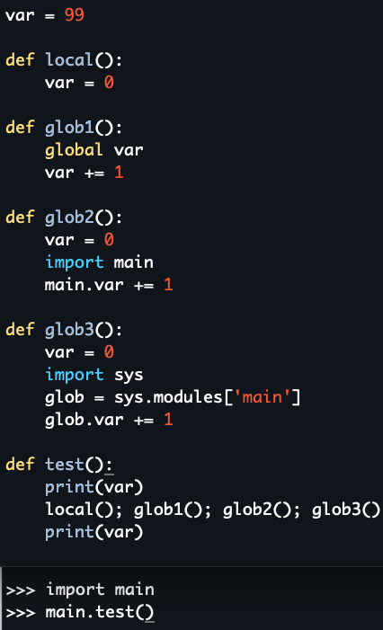

99 100

Syntax error

99 102

99 100 101 102

Clear selection

What will be the output of the following code?

10 points

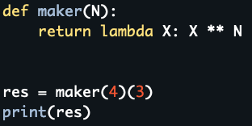

12

64

81

ValueError

What will be the output of the following code?

10 points

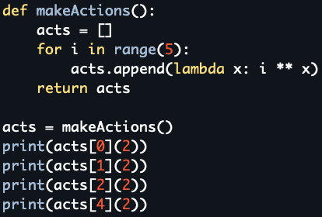

16 16 16 16

1 4 16 64

0 1 4 16

IndexError

What will be the output of the following code?

10 points

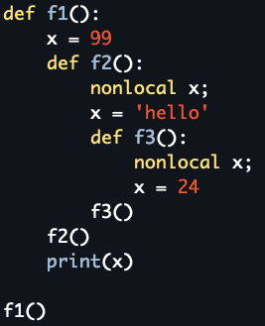

hello

99

24

SyntaxError: no binding for nonlocal 'x' found

What will be the output of the following code?

10 points

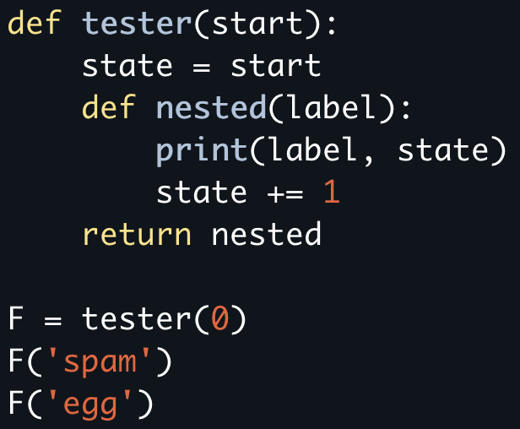

UnboundLocalError: local variable 'state' referenced before assignment

spam 0 egg 0

spam 0 egg 1

spam 1 egg 1

Which of these statements are true?

10 points

Each function can have multiple, divergent purposes.

Each function should be relatively small.

Use arguments for inputs and return for outputs.

Use global variables always

Avoid changing variables in another module file directly.

Use global variables only when truly necessary.

What will be the output of the following code?

10 points

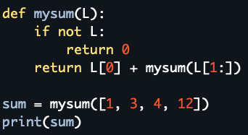

4 8 12 36

ValueError

0

20

Which statement is true about lambda functions?

10 points

lambda is a statement not an expression

lambda is an expression, not a statement.

it is not possible to test a conditional operation inside a lambda function

it is not possible to have nested lambda in lambda

What will be the output of the following code?

10 points

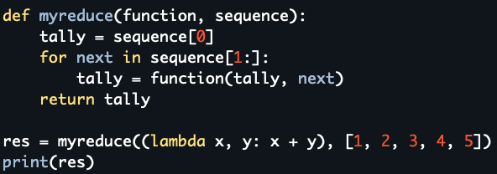

15

25

14

Syntax Error

Submit

Clear form

Never submit passwords through Google Forms.

Bottom of Form

This content is neither created nor endorsed by Google. [Report Abuse](https://docs.google.com/forms/u/0/d/e/1FAIpQLSfs6nMy3w0GNsivol96Phq7JEN7vD_7BC9gS4IQlMQmVzk66A/reportabuse?source=https://docs.google.com/forms/d/e/1FAIpQLSfs6nMy3w0GNsivol96Phq7JEN7vD_7BC9gS4IQlMQmVzk66A/viewform?usp%3Dsend_form) - [Terms of Service](https://policies.google.com/terms) - [Privacy Policy](https://policies.google.com/privacy)

[Forms](https://www.google.com/forms/about/?utm_source=product&utm_medium=forms_logo&utm_campaign=forms)